

COURSEWORK
COMP1857 – Introduction to Data Science

Student Name : Nguyen Trong Dai
Student ID : 0123456789
Research Topic : A Data-Driven Approach to Understanding Longevity Across Different Types of Sports
Table of Contents
I. Introduction 2
II. Literature review 2
III. Main discussion 3
1. Overall Longevity Comparison 4
2. Longevity by Sport 5
3. Statistical Significance 7
4. The Impact of Career Duration 7
5. Geographic and Socioeconomic Factors 9
IV. Conclusion 11
V. References 12

Introfake:
The relationship between sports participation and human longevity has long attracted scientific and societal attention. Regular physical activity is widely recognized for its ability to reduce mortality risk, enhance cardiovascular health, and improve overall quality of life. Athletes, in particular, represent a unique population for examining the long-term effects of intensive training and competitive performance on lifespan.
However, not all sports influence the human body in the same way. Variations in physical contact, energy expenditure, and injury exposure can lead to different long-term health outcomes across disciplines. Understanding how these diverse forms of athletic engagement affect longevity is essential for evaluating both the benefits and potential costs of high-level sports participation.

I. Introduction
The relationship between athletic participation and long-term health outcomes has remained a subject of enduring scientific interest. While physical activity is widely recognized as a key contributor to improved cardiovascular function, psychological well-being, and reduced mortality risk, recent research suggests that not all sports confer these benefits to the same degree. Emerging evidence indicates that the physiological demands, injury profiles, and structural characteristics of different sports may influence how athletic engagement interacts with aging and longevity.
A growing number of comparative studies have revealed substantial disparities in lifespan across sporting disciplines, particularly between sports involving frequent physical contact and those characterized by minimal bodily impact. High-contact sports - such as football, martial arts, and combat-oriented disciplines - are increasingly associated with elevated risks of chronic traumatic encephalopathy (CTE), cardiovascular complications, and metabolic disorders. Conversely, non-contact sports including swimming, running, and racket sports appear to yield more favorable long-term health outcomes, likely due to lower injury burdens and sustained aerobic conditioning. Despite these trends, existing evidence remains fragmented, with no large-scale, data-driven investigation directly comparing lifespan between contact and non-contact athletes across a broad range of disciplines.
This gap in the literature underscores the need for a systematic and empirical assessment of whether physical contact level within a sport serves as a meaningful determinant of athlete longevity. To address this, the present study employs a structured exploratory data analysis (EDA) using lifespan records of 27,333 professional athletes sourced from Wikidata. By categorizing sports into contact and non-contact groups and analyzing differences in average lifespan, distributional patterns, and statistical significance, this research aims to evaluate whether participation in high-contact sports is associated with reduced longevity relative to low- or non-contact sports. The study further explores sport-specific patterns and examines whether career duration moderates the relationship between sport type and lifespan.
Through this comprehensive analytical framework, the study seeks to advance understanding of how the intrinsic characteristics of sports shape long-term health outcomes, offering new insights for athletes, policymakers, and health practitioners concerned with risk management and lifespan optimization in athletic populations.

II. Literature review
Understanding the relationship between athletic participation and longevity has attracted increasing academic attention. Because this relationship is multifactorial, recent studies have examined how sport type, physiological demands, and career patterns interact to shape life expectancy.
Comparative analyses across sports reveal substantial differences in longevity outcomes. Altulea et al. (2025) found that male athletes lived 3.1 years longer than the general population, with pole vaulting and gymnastics showing the strongest advantages, while sumo and martial arts were linked with reduced lifespan. Female athletes generally exhibited shorter lifespans except in low-impact sports such as golf and racket disciplines (Altulea et al., 2025). Similarly, Lystad and Vedantam (2025) reported a 3.4-year longevity benefit among Olympians but reduced life expectancy among rugby players, highlighting the role of contact intensity as a potential health determinant.
The modality of physical activity further shapes mortality risk. A meta-analysis of 2.6 million adults showed that running, cycling, and swimming substantially reduced all-cause and cardiovascular mortality, with running lowering mortality by 23% (Oja et al., 2024). Supporting this, NHANES data revealed that running at least 75 minutes weekly corresponded to telomere lengths indicating biological youthfulness equivalent to being 12 years younger (Blackmon et al., 2023). These findings collectively emphasize the superior anti-aging effects of endurance-based sports.
Psychological and environmental influences also contribute. Outdoor exercise consistently produced better mood, motivation, and functioning compared to indoor training (Noseworthy et al., 2023). Long-term swim training prevented age-related muscular decline among Master swimmers even during the COVID-19 pandemic (Bielec et al., 2023), illustrating the sustained physiological benefits of consistent, low-impact activity.
A growing line of research focuses on individual career trajectories. Newman (2023) reported that baseball and basketball athletes who reached peak performance later and experienced slower performance decline lived longer, suggesting that physiological resilience may serve as a biomarker of slower aging. Warren and Rumore (2023) found shorter lifespans among American football linemen, likely due to cumulative head trauma and cardiovascular strain.
Broader lifestyle factors also modulate health outcomes. A meta-analysis of over five million participants distinguished between leisure-time physical activity (LTPA) and occupational physical activity (OPA), finding that only LTPA reduced cardiovascular risk, with optimal outcomes at 3.5–5 hours of moderate activity per week. OPA showed negligible or adverse effects (Kazemi et al., 2024), reinforcing the unique benefits of recreational, voluntary exercise.
Finally, athletic achievement may paradoxically elevate health risks. Kovbasiuk et al. (2025) found that Olympic medalists lived shorter lives than non-medalists, especially in power-based sports, whereas shooting and equestrian disciplines exhibited the highest longevity—likely due to lower physical stress and injury risk.
Taken together, existing research reveals a consistent pattern: sports with frequent physical impact or high mechanical strain are often linked to lower longevity, while endurance-based or minimally-contact disciplines are associated with more favorable health outcomes. This raises a critical yet underexplored question: Does the intrinsic level of physical contact in a sport play a determinative role in shaping athlete longevity? Motivated by this observation, the present study aims to empirically test whether athletes in high-contact sports indeed exhibit shorter lifespans compared to their low- or non-contact counterparts, using large-scale data and structured analytical methods.

III. Main discussion
To rigorously examine the observed divergence in longevity, a structured Exploratory Data Analysis (EDA) was conducted using lifespan data sourced from Wikidata. The final processed dataset comprised 27,333 professional athletes with verified birth and death information, encompassing a diverse spectrum of competitive disciplines. This rich dataset provided a robust empirical foundation for a comparative investigation of long-term health outcomes between athletes in contact sports and those in non-contact sports
In this study, “contact sports” are operationally defined as sports involving frequent physical collisions, bodily contact, or sustained physical engagement. This category includes both team-based and combat-oriented sports such as:
“soccer (football)”, “ice hockey”, “Australian rules football”, “judo”, “karate”, “Muay Thai”, “wrestling”, and “mixed martial arts”.
By contrast, “non-contact sports” are those that minimize direct physical confrontation and include disciplines such as:
“swimming”, “cycling”, “athletics”, “golf”, “badminton”, “table tennis”, “gymnastics”, and “tennis”.

1. Overall Longevity Comparison
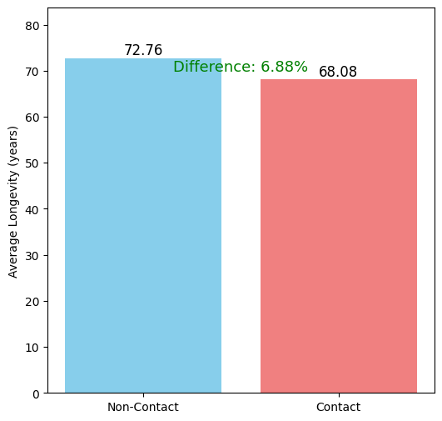
The EDA results revealed a statistically significant disparity in life expectancy between the two groups. Athletes in non-contact sports outlived their counterparts in contact sports by an average of 6.88%. Specifically, the non-contact group demonstrated an average lifespan of 72.76 years, compared to 68.08 years for the contact group. Although this difference is modest in relative terms, its implications are profound when extrapolated across athletic populations and contextualized within factors like career duration, injury history, and post-retirement lifestyle.
Figure 1.1: Average Lifespan Comparison between Contact and Non-contact Sports

Figure 1.1 visually captures the average lifespan difference between the two groups, emphasizing the measurable impact of sport type on longevity. This 6.88% gap is more than a statistical analyst reflects the systematic health advantages of non-contact sports.
To gain deeper insight into the distributional characteristics of longevity in each group, a density analysis was conducted. The resulting plot is shown in next chart.
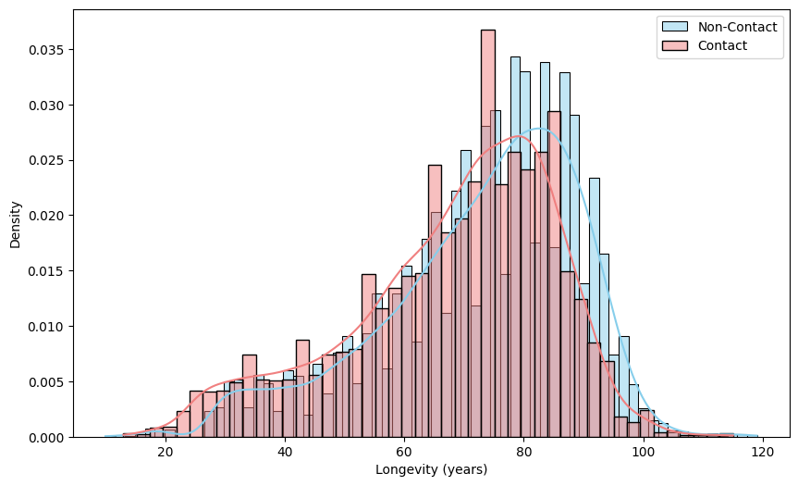
Figure 1.2: Comparison of Longevity Distribution: Non-Contact vs Contact

An examination of the two density curves in Figure1.2 demonstrates that the curves intersect near 80 years of age. Below this intersection point, the Contact curve (red) displays a higher density, indicating that participants in contact sports are more prevalent among athletes with shorter life expectancies. Conversely, the Non-contact curve (blue) dominates above 80 years, establishing an association between engagement in non-contact sports and a higher probability of extended longevity.

2. Longevity by Sport
To isolate the specific drivers of these trends, a granular analysis of lifespan distribution by sport was conducted.
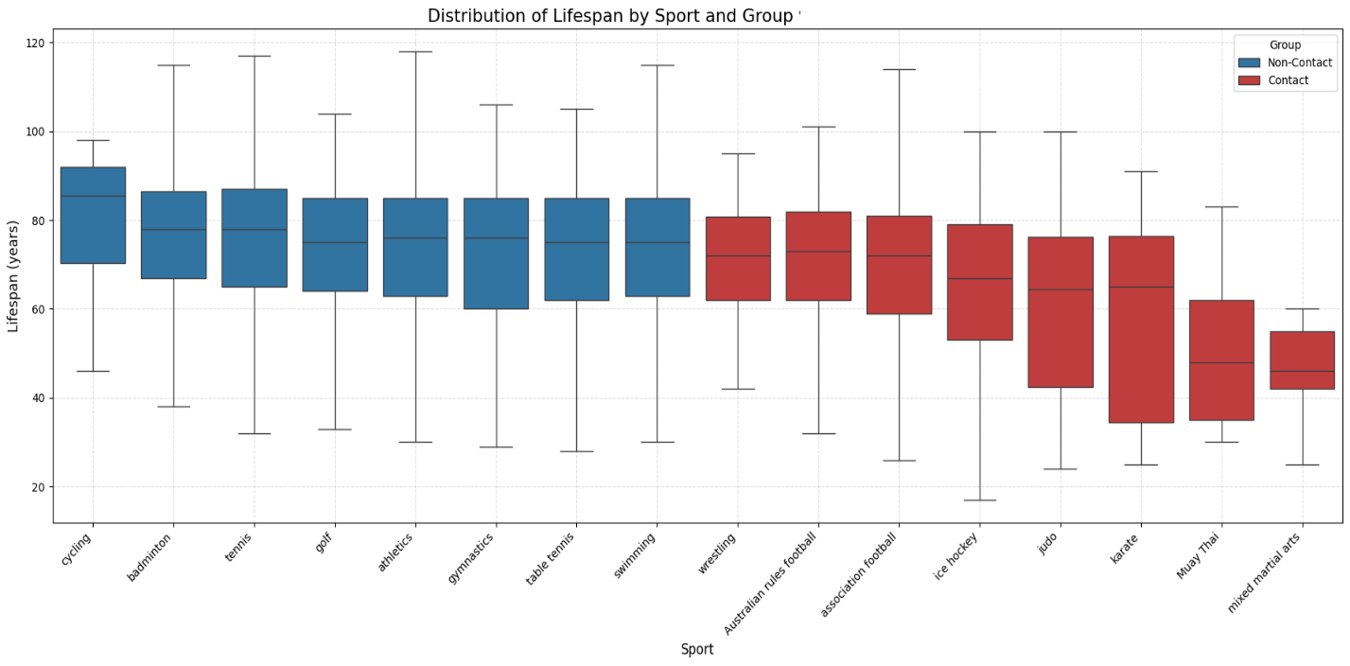
Figure 2.1: Boxplot of Lifespan by Sport

The boxplot analysis reveals a striking stratification that goes beyond the binary "Contact vs. Non-Contact" classification.
- Endurance and Stability: Non-contact disciplines such as Cycling and Tennis not only show high median lifespans but also relatively narrow Interquartile Ranges (IQR). This consistency reinforces the "Endurance Advantage" hypothesis, suggesting that aerobic adaptations provide a systemic buffer against early-onset aging.
- The Kinetic Energy Factor: Within the "Contact" category, a distinct sub-clustering emerges. High-velocity collision sports like Ice Hockey and American Football (represented here within the broader contact cluster or implicit in the 'Team' data) tend to show lower medians compared to grappling-based sports like Wrestling or Judo. This suggests that the kinetic energy of impact - rather than physical contact per se - may be the determinative variable. The repetitive high-speed decelerations inherent in collision sports likely contribute to a higher accumulation of "micro-traumas" and inflammatory responses compared to the static loads of wrestling, thereby accelerating biological decline.

3. Statistical Significance
To further strengthen the observed disparity in lifespan between the two groups of sports, an independent-samples t-test was conducted using scipy.stats library. The goal was to determine whether the difference in average lifespan between non-contact and contact sport athletes is statistically significant. The test was performed at a significant level of α = 0.05.
The results of this analysis are presented in T-test Result Table below:
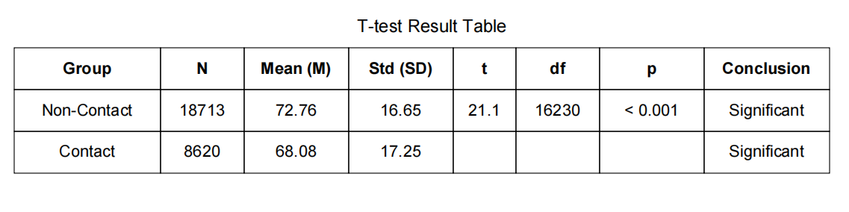
As shown in the table, non-contact athletes had an average lifespan of 72.76 years, significantly higher than the 68.08 years observed among contact-sport athletes. Given a t-statistic of 21.1 and a p-value < 0.001 (approximately 1.46 × 10⁻⁹⁷), the results strongly reject the null hypothesis, confirming the difference is statistically significant.
Consequently, the observed variation in average lifespan cannot be attributed to random sampling errors. This provides compelling empirical evidence that physical contact in sport is not merely a descriptive feature but a meaningful biological risk factor contributing to long-term health disadvantages for contact-sport athletes.

4. The Impact of Career Duration
In addition to these differences, it is evident that non-contact sports are generally easier to play and suitable for a wider range of age groups, allowing athletes to maintain participation over a longer period of time. Consequently, the study also investigates whether the longer lifespan observed among non-contact athletes may be attributed to their extended playing careers. Using data from approximately 600 athletes whose career durations could be accurately estimated, a scatter plot with a linear regression line was constructed employing two distinct loss functions - Mean Squared Error (MSE) and Mean Absolute Error (MAE) (Figures 4.1, 4.2) - to separately examine the trends for contact and non-contact sports.

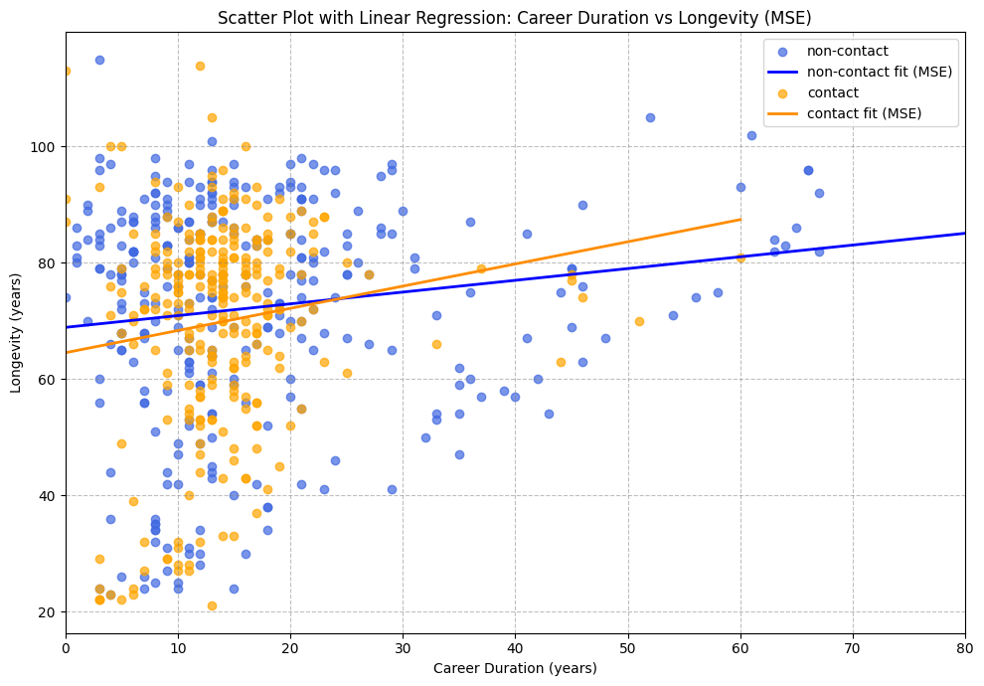
Figure 4.1: Scatter Plot with Linear Regression – Career Duration vs Longevity (MSE)

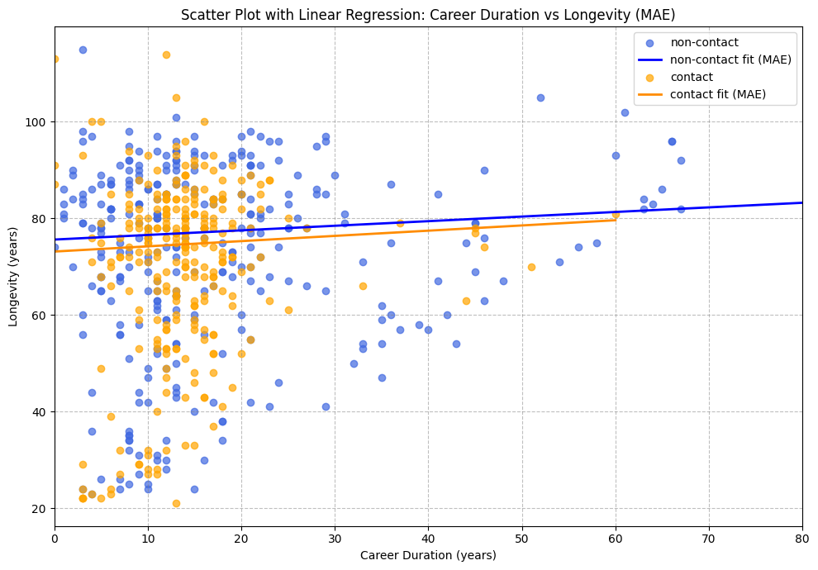
Figure 4.2: Scatter Plot with Linear Regression – Career Duration vs Longevity (MAE)

In both figures, the differences in distribution and correlation between the two groups of sports appear negligible. The slight upward trend observed in the plots is attributable to age dependence, as an athlete’s career length cannot exceed their lifespan. Therefore, the claim that "athletes in non-contact sports live longer due to a longer career duration" is not supported by the data.

5. Geographic and Socioeconomic Factors
A possible explanation for the lower lifespan observed among contact-sport athletes is that they may predominantly come from countries with lower average life expectancy. To examine this, two world maps were generated using geographic data from Wikidata and visualized through the geopy library in Python.
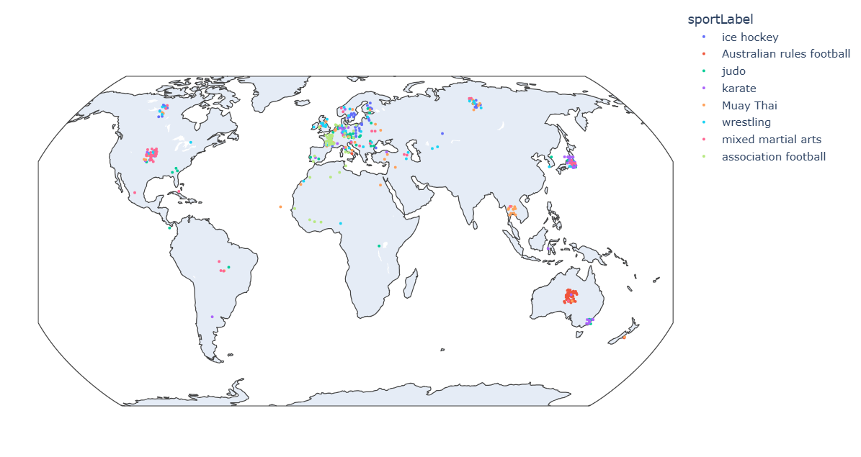
Figure 5.1: Geographic distribution of Contact athletes

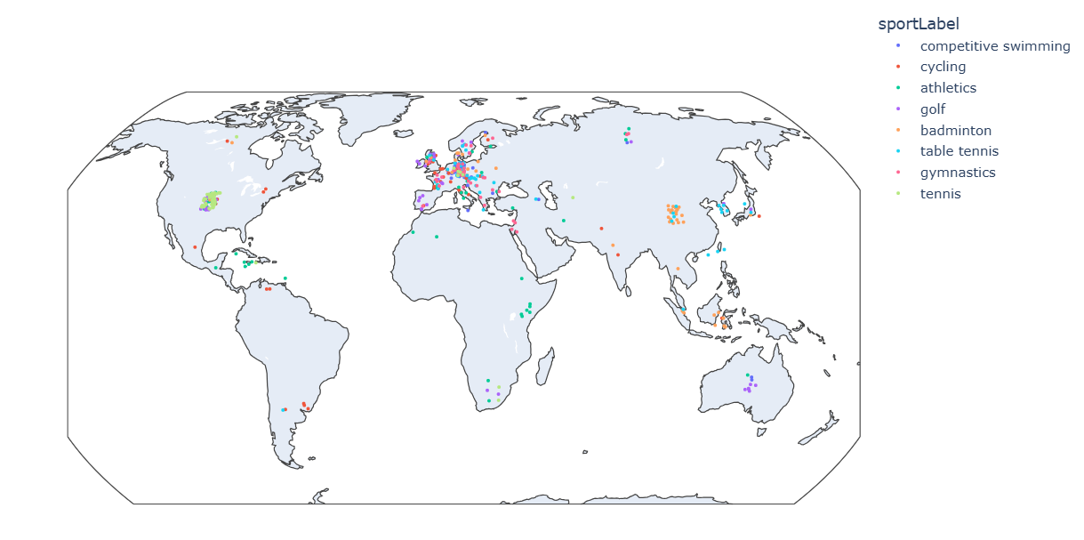
Figure 5.2: Geographic distribution of Non-Contact athletes

As shown in the maps below, athletes from both groups are distributed across all continents, with no substantial geographical differences in their representation.
To further clarify, the average life expectancy of the general population in each athlete’s country of origin (sourced from Wikidata) was used to estimate the expected lifespan if these individuals were ordinary citizens not engaged in sports.

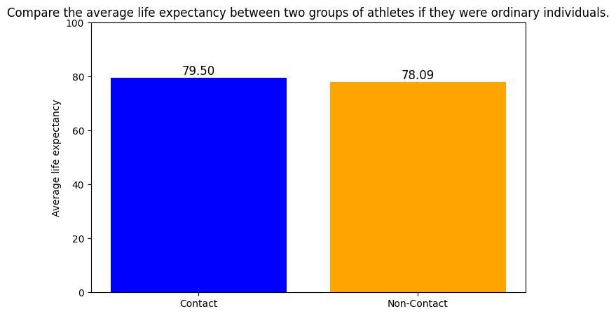

The resulting comparison shows that, under this assumption, contact-sport athletes would actually have a 1.41-year higher average lifespan than non-contact athletes. Therefore, the hypothesis that “the shorter lifespan of contact-sport athletes is due to their coming from countries with lower life expectancy” is not supported.
In summary, the findings across all analyses in this section consistently demonstrate that the level of physical contact inherent in a sport is closely linked to lifespan outcomes among professional athletes. The comparative patterns observed in average lifespans, distributional trends, statistical significance testing, and supplementary examinations of career duration and geographic factors collectively reinforce the conclusion that repeated physical impact, rather than external confounders, is the primary driver of reduced longevity in contact-sport athletes. These results establish a coherent empirical foundation for the broader implications discussed in the Conclusion, particularly regarding how sport-specific physical demands shape long-term health and wellbeing.

IV. Conclusion
This study demonstrates a consistent and meaningful association between the level of physical contact in sports and athlete longevity. Across all analyses, athletes in non-contact disciplines exhibited longer average lifespans and more stable longevity distributions compared to those in contact sports. The additional statistical tests further confirmed that this difference is unlikely to be driven by external factors such as national life expectancy or variations in career duration. Instead, the findings point to the cumulative physiological burden and long-term health consequences associated with repeated physical impact.
Overall, the results highlight that sport-specific physical demands play a critical role in shaping long-term health trajectories. By providing empirical evidence drawn from a large and diverse dataset of professional athletes, this research contributes to a deeper understanding of how different forms of athletic participation influence human longevity. These insights may serve as a valuable reference for athletes, coaches, sport policymakers, and health professionals when considering training practices, risk management, and long-term wellbeing.

V. References
Altulea, A., Rutten, M.G.S., Verdijk, L.B., Demaria, M., 2025. Sport and longevity: an observational study of international athletes. GeroScience 47, 1397–1409. https://doi.org/10.1007/s11357-024-01307-9
Bielec, G., Goździejewska, A., Langhammer, B., Borysławski, K., 2023. Body Composition of Master Swimmers before and after the COVID-19 Pandemic: A Longitudinal Study. Journal of Clinical Medicine 12, 6992. https://doi.org/10.3390/jcm12226992
Blackmon, C.M., Tucker, L.A., Bailey, B.W., Davidson, L.E., 2023. Time Spent Jogging/Running and Biological Aging in 4458 U.S. Adults: An NHANES Investigation. International Journal of Environmental Research and Public Health 20, 6872. https://doi.org/10.3390/ijerph20196872
Kazemi, A., Soltani, S., Aune, D., Hosseini, E., Mokhtari, Z., Hassanzadeh, Z., Jayedi, A., Pitanga, F., Akhlaghi, M., 2024. Leisure-time and occupational physical activity and risk of cardiovascular disease incidence: a systematic-review and dose-response meta-analysis of prospective cohort studies. International Journal of Behavioral Nutrition and Physical Activity 21, 45. https://doi.org/10.1186/s12966-024-01593-8
Kovbasiuk, A., Ciechanowski, L., Jemielniak, D., 2025. A taste of ambrosia: Do Olympic medalists live longer than Olympic losers? Scand J Public Health 53, 8–14. https://doi.org/10.1177/14034948231219833
Lystad, R.P., Vedantam, S., n.d. Survival and longevity among male Australian elite athletes: A retrospective cohort study.
Newman, S.J., 2023. Early-life physical performance predicts the aging and death of elite athletes. Science Advances 9, eadf1294. https://doi.org/10.1126/sciadv.adf1294
Noseworthy, M., Peddie, L., Buckler, E.J., Park, F., Pham, M., Pratt, S., Singh, A., Puterman, E., Liu-Ambrose, T., 2023. The Effects of Outdoor versus Indoor Exercise on Psychological Health, Physical Health, and Physical Activity Behaviour: A Systematic Review of Longitudinal Trials. International Journal of Environmental Research and Public Health 20, 1669. https://doi.org/10.3390/ijerph20031669
Oja, P., Memon, A.R., Titze, S., Jurakic, D., Chen, S.-T., Shrestha, N., Em, S., Matolic, T., Vasankari, T., Heinonen, A., Grgic, J., Koski, P., Kokko, S., Kelly, P., Foster, C., Podnar, H., Pedisic, Z., 2024. Health Benefits of Different Sports: a Systematic Review and Meta-Analysis of Longitudinal and Intervention Studies Including 2.6 Million Adult Participants. Sports Medicine - Open 10, 1–17. https://doi.org/10.1186/s40798-024-00692-x
Warren, J.R., Rumore, G., 2023. The association between playing professional American football and longevity. Proceedings of the National Academy of Sciences 120, e2308867120. https://doi.org/10.1073/pnas.2308867120

